Brain Tumor Detection using Deep Learning Models

Project Report Submitted to the SRM University-AP, Andhra Pradesh
for the partial fulfillment of the requirements to award the degree of

Bachelor of Technology in
Computer Science & Engineering School of Engineering & Sciences
submitted by
Aniket Mishra (AP22110011529)
Sijan Oli (AP22110011530)
Aman Kapad (AP22110011533)
Moussa Dembele (AP22110011631)
Under the Guidance of

Dr. Tonmoya Sarmah

Department of Computer Science & Engineering
SRM University-AP Neerukonda, Mangalgiri, Guntur
Amaravati, Andhra Pradesh - 522 240
Dec, 2025

DECLARATION

We, the undersigned, hereby declare that the project report titled "Brain Tumor Detection using Deep Learning Models", submitted in partial fulfillment of the requirements for the award of the degree of Bachelor of Technology in Computer Science & Engineering at SRM University-AP, represents the bonafide work carried out by us under the supervision of Dr. Tonmoya Sarmah.
This submission embodies our ideas expressed in our own words. Where the ideas or words of others have been included, we have ensured adequate and accurate citation and referencing of the original sources. We affirm that we have adhered to the ethics of academic honesty and integrity and have not misrepresented or fabricated any data, idea, fact, or source in this submission.
We understand that any violation of the above shall be cause for disciplinary action by the institute and/or the University and may also evoke penal action from the sources that have not been properly cited or from whom proper permission has not been obtained.
We further declare that this work, in whole or in part, has not been previously submitted as the basis for the award of any degree, diploma, or other qualification at this or any other University.

Place : SRM University, AP Date : December 5, 2025
Name of student : Aman kapad Signature :
Name of student : Sijan Oli Signature :
Name of student : Aniket Mishra Signature :
Name of student : Moussa Dembele Signature : .

DEPARTMENT OF COMPUTER SCIENCE & ENGINEERING
SRM University-AP Neerukonda, Mangalgiri, Guntur
Amaravati, Andhra Pradesh - 522 240


CERTIFICATE
This is to certify that the report entitled Brain Tumor Detection using Deep Learning Models submitted by Aniket Mishra, Sijan Oli, Aman Kapad and Moussa Dembele to the SRM University-AP in partial fulfillment of the requirements for the award of the Degree of Bachelor of Technology in the Department of Computer Science & Engineering is a bonafide record of the project work carried out under my guidance and supervision. This report in any form has not been submitted to any other University or Institute for any purpose.

Project Guide
Name : Dr. Tonmoya Sarmah Name : Dr. Murali Krishna Enduri Signature: 

ACKNOWLEDGMENTS
We wish to express our sincere gratitude to all individuals whose guidance and support were instrumental in the completion of this UROP project report, titled “Brain Tumor Detection using Deep Learning Models.”
We​‍​‌‍​‍‌​‍​‌‍​‍‌ would like to express our highest thankfulness to our project supervisor, Dr. Tonmoya Sarmah, Department of Computer Science & Engineering, for her invaluable mentorship, insightful suggestions, and consistent guidance throughout the course of this work. Without her expertise and critical comments, it would have been very difficult to define the quality and the content of this research.

We also thank Dr. Murali Krishna Enduri, Head of the Department of Computer Science & Engineering, for his support in terms of resources and providing a research-friendly environment.

Besides this, we thank and acknowledge the support and encouragement of our colleagues and friends. Their willingness to participate in discussion and give feedback on our presentation helped us a lot to be clear and confident.

Last but not least, we thank the Undergraduate Research Opportunities Program (UROP) for giving us the opportunity to carry out this important ​‍​‌‍​‍‌​‍​‌‍​‍‌investigation..

Aniket Mishra (AP22110011529)
Sijan Oli (AP22110011530)
Aman Kapad (AP22110011533)
Moussa Dembele (AP22110011631)
B. Tech. Department of Computer Science & Engineering
SRM University-AP

ABSTRACT

This​‍​‌‍​‍‌​‍​‌‍​‍‌ research creates and tests an automated diagnostic system that incorporates magnetic resonance imaging (MRI) and deep learning for the identification and classification of brain tumors. The system aims to categorize MRI images into one of four classes: glioma, meningioma, pituitary tumor, or no tumor. A significant portion of the work was devoted to comparing various deep-learning architectures. Among these were pre-trained convolutional neural networks (CNNs) such as ResNet50, different variants of VGG, DenseNet121, InceptionV3, MobileNet, as well as custom hybrid or ensemble models like VGG19 + ResNet50. The project stages included thorough data preparation, which involved assembling a publicly available MRI dataset, image preprocessing, and applying enhancement methods to widen the model's applicability. Following the initial comparative analysis, the research concentrated on enhancing performance by hyperparameter tuning and architectural modifications of the most promising single models and ensembles, particularly VGG19 and VGG19+ResNet50. Additional work has been accomplished on InceptionV3 architecture to make it more feature extraction capable. The experimental results indicate that the ensemble model refined through various optimizations attains higher classification accuracy and shows greater robustness than the individual networks. In addition, this work illustrates the approach taken to address significant computational issues encountered when training complex models on large-scale medical image data. Their findings underscore the potential of advanced, optimized deep learning systems as effective, powerful, and reliable support tools in medical diagnosis, thus leading to more accurate, time-saving and easily scalable solutions for brain tumor ​‍​‌‍​‍‌​‍​‌‍​‍‌detection.

CONTENTS

ACKNOWLEDGMENT 4

ABSTRACT 5
LIST OF TABLES 8
LIST OF FIGURES 9
Chapter 1. INTRODUCTION TO THE PROJECT
  - Background and Problem Statement 10
  - Project Objectives 11
Chapter 2. MOTIVATION 12
  - Reasons Why Final Year Engineering Projects Are Im- portant 13
    - Identifying Real-Time Problems and Developing
Solutions 13
    - Exploring Research Areas 14
    - Choosing the Right Topic and Mentor 14
    - Mastering Project Documentation and
Communication 15
    - The Importance of Good Planning 15
2.1.6 A Chance for Self-Expression and Specialization 15

Chapter 3. LITERATURE SURVEY 16
3.1 How Methods in Medical Image Analysis Have Changed 16
3.2 Works done in the field of classifying Brain Tumors 17
3.3 Identified Research Gap and This Project's Position 18

Chapter 4. DESIGN AND METHODOLOGY 19
  - Engineering Design done in project 20
  - Project Framework 21
Chapter 5. IMPLEMENTATION 22
5.1 Development Environment and Setup 23
5.2 Data Pipeline Implementation 23
5.3 Model Development and Architecture 24
5.4 Training Configuration and Execution 25
5.5 Evaluation and Analysis Implementation 27
Chapter 6. HARDWARE/ SOFTWARE TOOLS USED 28
6.1 Hardware/Software Infrastructure
Chapter 7. RESULTS & DISCUSSION 33
7.1 Presentation of Results 33
7.2 Discussion of Findings 36
Chapter 8. CONCLUSION 37
  - Project Summary and Conclusions 38
8.2 Scope for Further Work 38
REFERENCES 40

LIST OF TABLES

4.1 Brain Tumor MRI Dataset Composition…………20

5.1 Hyperparameter Table………………………………26/27

7.1 Performance of Individual Pre-trained CNN Models ..33/34

LIST OF FIGURES

2.1 The Role of the Final Year Project in Engineering Education………………………………………………13

2.2 From Research Ideas to Real Projects…………….14

5.1: Software Stack Architecture…………………..24

6.1: Overview of Google Colab Hardware ………….29

6.2: Local Development Setup ……………………30

6.3: Sample Training and Validation Accuracy/Loss Plots…31

6.4: Version Control Workflow……………32

7.1: Confusion Matrix for VGG19+ResNet50 Ensemble Model…………35

7.2: Training and Validation Curves for VGG19……35

9

Chapter 1 INTRODUCTION TO THE PROJECT
This​‍​‌‍​‍‌​‍​‌‍​‍‌ chapter introduces a report to the project. It helps the readers to know what kind of work was performed. It tells about the project coverage, its main objectives, and the expected outcome, and also illustrates the time when the work was done. The idea behind this part is to explain the project's origin, main concept, and expected results so that the subsequent chapters can be easily grasped.
1.1 Background and Problem Statement
Brain tumors are a major and complex problem in today's medicine and they are basically the result of abnormal cells that grow uncontrolled in the brain's delicate and complicated structure. The condition comprises more than 120 different types that have significant differences in their growth, location, and biological properties. The brain is the most complex organ in the body and it is the control center for all the body's functions, that is why any kind of cancer or abnormality in this organ has a strong impact. The patient's prognosis depends on the tumor's type, grade, and most importantly, the promptness, and accuracy of its initial detection. Early detection is very important as it not only saves lives but also determines the surgical intervention's extent, and the choice of adjuvant treatments like radiation or chemotherapy, thus it has a very strong influence on both survival rates and quality of life.
In the domain of medical imaging, Magnetic Resonance Imaging (MRI) has been considered the foremost non-invasive technique for brain imaging for a long time. It utilizes no ionizing radiation and offers unparalleled visualization of soft tissue contrast. The state-of-the-art, multi-sequence imaging capabilities of the MRI machine—such as T1-weighted, T2-weighted, and Fluid-Attenuated Inversion Recovery (FLAIR)—enable radiologists to precisely delineate normal structures and identify pathological changes with great accuracy. However, despite these technological improvements, the core diagnostic method is still largely manual and qualitative. A neuroradiologist or specialist is required to perform a mentally highly demanding and laborious task of going through in great detail hundreds of individual slices in an MRI examination, looking for minute differences in intensity, texture, and morphology, and using his/her knowledge to separate these changes from each other - healthy tissue, edema, tumor types. Being a subjective matter, the procedure also has the drawback of inter-observer variability, meaning a different expert will come to a different conclusion for the same ​‍​‌‍​‍‌​‍​‌‍​‍‌scan.

1.2 Project Objectives
The​‍​‌‍​‍‌​‍​‌‍​‍‌ primary aim of this endeavor is to conceive, execute, and evaluate a potent deep learning-based framework that is capable of automated detection as well as classification of brain tumours on MRI images. For this, it is essential to perform a comprehensive comparative analysis of state-of-the-art Convolutional Neural Network (CNN) architectures and also explore the sophisticated ensemble methods to improve the diagnostic accuracy. The ultimate goal is to generate a functional prototype that not only demonstrates the practical use of AI as a reliable assistant in radiology but also makes it possible for the end-users to get the benefit of quick, consistent, and convenient preliminary diagnoses.
- It includes defining the standard steps for data preparation, model designing, and setting up an efficient procedure for model training and testing.
- This involves setting up standard steps for preparing the data, building model designs, and setting up a strong process for training and testing the models.
- The objective is to examine their performance, efficiency, and appropriateness for medical image classification through transfer learning.
- To develop and evaluate the hybrid or ensemble models that intend to increase the prediction accuracy, mitigate the difference of results between models, and ensure the models' stability more than single model usage.
- These mixed models could use methods like averaging results, stacking models, or combining features from different models.
- The aim is to produce a functional application depicting how AI can help doctors by utilizing the trained models in a friendly way, thus facilitating brain tumour ​‍​‌‍​‍‌​‍​‌‍​‍‌diagnoses.

Chapter 2
Motivation
This​‍​‌‍​‍‌​‍​‌‍​‍‌ chapter presents the main reasons for starting this project, emphasizing its significance not only within the academic curriculum but also its considerable implications for society. It looks at the ways the project serves as a bridge between the theoretical principles of engineering and the practical application of these principles to solve healthcare problems. Moreover, the chapter outlines various professional and technical skills that students can acquire from this experiential, research-oriented medical AI project.
2.1 Reasons Why Final Year Engineering Projects Are Important

The final year engineering project is beyond the mere requirement of the course; it is a significant turning point from the theoretical learning of engineering to the actual application of engineering skills.
While the idea of the project may be based on the work of others, what really matters is the extent to which the project is unique and profound. This last experience equips students not only with the technical skills but also with the important professional abilities and it prepares them for the engineering challenges of the real world. It is the connection between the knowledge gained in class and its application in real life.
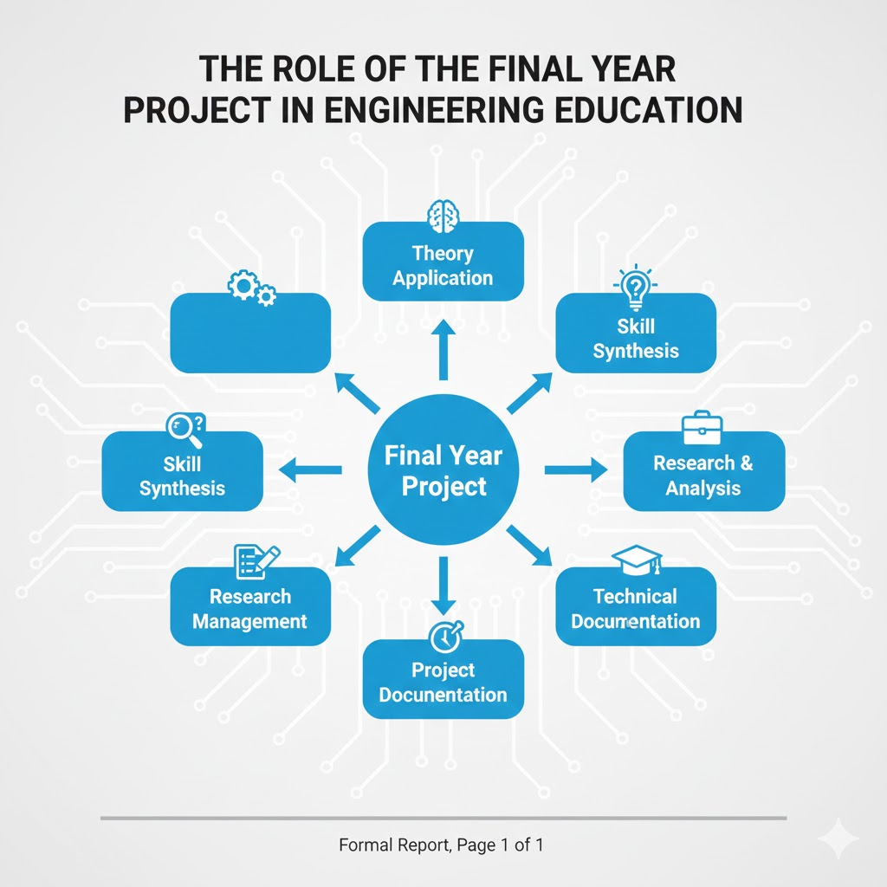

Figure 2.1: The Role of the Final Year Project in Engineering Education

2.1.1 Identifying Real-Time Problems and Developing Solutions

The best projects originate from the need to solve real, current problems. This procedure begins with identifying a real-world problem – a step that fosters creativity and promotes deep thinking. We decided to address a major issue in healthcare for our project: the requirement of fast, accurate, and user-friendly methods for the detection of brain tumors in MRI scans. Manually reading these scans may be accurate, but it is very time-consuming and the results may vary, especially in areas where there is a shortage of specialists.
By selecting this subject, we were able to combine our knowledge of computer science and machine learning to ease a real problem that is a matter of concern for society. It compelled us to think not only in terms of the technical aspect of constructing something but also of how our work could bring about a significant change in the real world.Addressing a real-time problem like this gave us the opportunity to reconsider the situation and realize how an engineering solution can make a difference in healthcare and also lead to the emergence of future startups or research projects in med-tech.
    - Exploring Research Area
Having a project in rapidly evolving fields such as medical AI entails a lot of different topics to research. We have been absorbing recent papers and articles with a focus on deep learning, convolutional neural networks (CNNs), and their application in medical image analysis. This has given us a comprehensive idea of the work that is currently being done, the methods that are already being utilized, and the avenues where there are opportunities to improve, e.g., by making a better use of ensemble learning techniques. These materials provided us not only with the fundamental knowledge but also with the latest technological trends required to shape our project. While diving into various scholarly materials, we were able to draft a solid project plan, backed up by intelligent concepts and working models, which greatly extended our learning beyond that of normal ​‍​‌‍​‍‌​‍​‌‍​‍‌lectures.
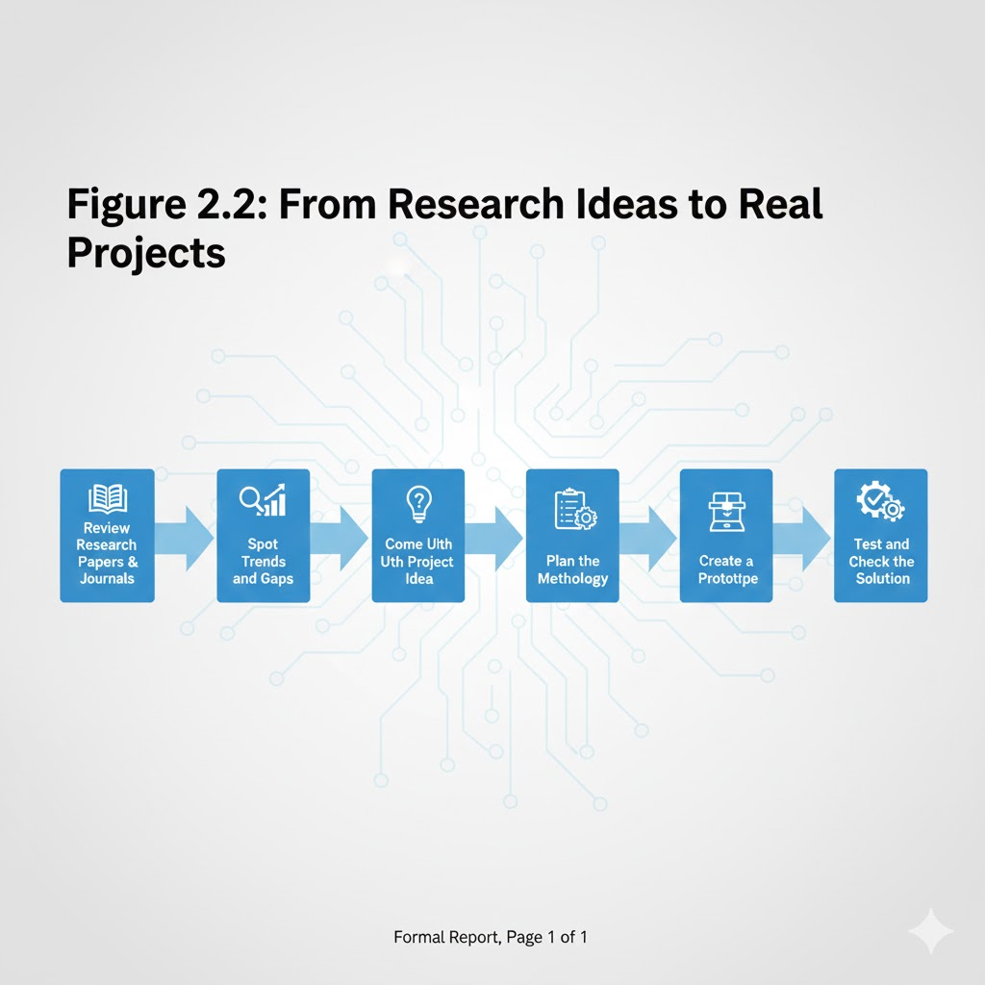
Figure 2.2: From Research Ideas to Real Projects

2.1.3 Choosing the Right Topic and Mentor
To​‍​‌‍​‍‌​‍​‌‍​‍‌ a great extent, the selection of the appropriate subject in conjunction with excellent guidance determines the outcome of the project to be successful. We decided to undertake the project "Detecting Brain Tumors Using Deep Learning Models" which is a good match for our team's interests in the fields of computer vision and healthcare. It gave us a chance to apply machine learning in solving a pressing problem. Collaborative work enabled us to come up with different ways of approaching the project, from selecting the right CNN models to planning how to merge them into an ensemble model, thereby enhancing our group's problem-solving and creative thinking skills. Our supervisor, Dr. Tonmoya Sarmah, was really supportive. Her experience with deep learning gave us direction, helped us concentrate on our objectives, and gave us strength when we faced technical difficulties. Her guidance was like a lighthouse helping us to delve deeper into our interests in such areas ​‍​‌‍​‍‌​‍​‌‍​‍‌as:
- Computer Vision and Image Processing
- Machine Learning and Artificial Intelligence
-Data Analytics and Computational Modeling

2.1.4 Mastering Project Documentation and Communication

Writing​‍​‌‍​‍‌​‍​‌‍​‍‌ and speaking skills, which are often neglected, have been enhanced through the final year project truly they are top-tier professional skills. This very report is a trial in the efficient coordination of complex information, clear explanation of methods, and communicating results and conclusions logically and in a structured manner. Being proficient in writing and speaking is of great importance later on as it is a demonstration of one's capability to clarify the central idea, the selection of the design, and the worth of a technical project.
This ability will also be handy during the job interviews, where one will be expected to talk about his/her project. Our writing, researching, and communication skills have been greatly enhanced through the creation of this report. The final year project is a signal to employers of the student's grasp of the core of engineering, technical skills, and knowledge of a particular field, which can be instrumental in shaping the student's ​‍​‌‍​‍‌​‍​‌‍​‍‌career.

2.1.5 The Importance of Good Planning

Effective​‍​‌‍​‍‌​‍​‌‍​‍‌ planning is one of the most important aspects of a successful project and it is the main reason why this experience is so valuable. Our project taught us to plan ahead by setting up different stages such as literature review, data preparation, model building, and analysis, assigning tasks according to people&rsquo;s strengths, time management, and also sketching out the project&rsquo;s overall framework.
This work helped the team develop skills in task organization, time management, and problem-solving such as the shortage of computer resources. Additionally, working on a project provides opportunities to improve leadership and content creation skills while teamwork helps to deepen group relationships and learn more from others.

2.1.6 A Chance for Self-Expression and Specialization

The final year project is a unique chance for students to reveal their own interests and apply their knowledge of certain technologies to come up with a real product. Our team&rsquo;s interest in machine learning and Python programming made this project an ideal way to broaden our skills in these fields. We were given the freedom to explore, experiment with ideas, and present our way of solving a particular problem.
This experience is beyond just fulfilling an academic requirement; it is instrumental in forming a professional identity. By engaging deeply in a field of their choice, students can get a clearer picture of their career path and identify areas for personal development and specialization. Moreover, the project becomes an important part of a portfolio that demonstrates initiative, knowledge, and the capability to carry out a major technical ​‍​‌‍​‍‌​‍​‌‍​‍‌task.

Chapter 3
LITERATURE SURVEY
This​‍​‌‍​‍‌​‍​‌‍​‍‌ chapter provides an extensive overview of the research that has been done in applying deep learning to the automatic detection of brain tumors.
A literature review is the most essential part of this work. It helps to locate the research question in the existing scientific knowledge and decide the appropriate methods to be used. The present chapter illustrates how the technologies have evolved from the old methods to the recent deep learning models, it also indicates the major trends and pinpoints the exact issue that the project is aimed at solving.

3.1 How Methods in Medical Image Analysis Have Changed
A substantial transformation has been made in the utilization of computers in medical diagnosis over the years. Before the 2010s, the majority of works in the field were based on traditional machine learning techniques. This method involved two key stages: one, feature extraction from MRI scans was done by the experts manually. The features normally described texture patterns (e.g. Gray-Level Co-Occurrence Matrices - GLCM), statistical properties, or the shape of the regions. Next, these features were inputted to train classical models like Support Vector Machines (SVM), k-Nearest Neighbors (k-NN), or Random Forests. Even though these approaches were somewhat successful in performing basic tasks, their outcomes were constrained because the features were human-made and did not take into account the intricate patterns of medical images.
One of the significant transformations happened with the advent of deep learning, particularly Convolutional Neural Networks (CNNs). These networks aim at doing the feature extraction automatically from the images just like the human brain's visual system does. CNNs learn to identify the regularities by themselves in the images via the layers of filters, pooling, and activation functions, starting with very basic things like edges and textures and going further to complex features. This made CNNs extremely successful in image classification. A revolutionary step was AlexNet in the 2012 ImageNet challenge, which eventually led to the creation of more sophisticated models like VGGNet, GoogleNet (Inception), and ResNet.
In the field of medical imaging, the lack of labeled data was one of the problems. To bypass this limitation, researchers embraced transfer learning. They brought in already trained CNNs which had been trained on vast natural image datasets such as ImageNet. These models had already mastered the detection of simple features like edges and shapes, which are also valid for medical images. By retraining the last layers of these models on medical data, researchers could obtain better results even with smaller datasets. Hence, it became easier to apply deep learning to areas that require specialization like radiology.

3.2 Works done in the field of classifying Brain Tumors
Recent works demonstrate that deeply supervised CNNs are the most common approach for brain tumor classification. A typical strategy is to pit several pre-trained models against each other. The paper also suggests that deeper architectures like ResNet50, DenseNet121, and InceptionV3 generally have better outcomes than shallower ones as they are capable of learning more complex features. This is the case, for instance, when Abiwinanda et al. (2019) applied a basic CNN for tumor classification whereas Sultan et al. (2020) carried out an extensive comparison and indicated that the ResNet-based models are stable. Researchers exploit ensemble learning to enhance the results. By doing so, they do not limit themselves to a single model but rather merge the outcomes of a few models like VGG16, ResNet50, and InceptionV3 through the techniques of averaging or voting to get the final result. The hypothesis is that since different models can learn different features, and therefore combining them leads to better results and less error. The research indicates that such ensembles generally outperform the best individual models.
Another direction is the development of new or hybrid architectures. By doing this, one surpasses the boundaries of the mere ensemble of models by amalgamating different parts of models or mixing deep learning with other techniques. Some examples from research include:
- CNN-SVM hybrids: using a CNN to extract features and an SVM for classification, thereby exploiting SVM's strength in handling high-dimensional data.
- Multi-path or fusion CNNs: constructing networks that take the inputs through different routes and merge the features at different stages.
- Attention-based mechanisms: inserting elements that enable the net to concentrate on the most significant parts of the input, thus making the model more interpretable and providing a possible accuracy increment.
- Furthermore, there is a growing concern over the transparency of models. One example is Grad-CAM, which identifies the regions of the input that had the most influence on the output. An explainable AI approach like this is a must for doctors to accept the model's verdict because it helps them to understand it, hence, it is no longer a black box but a tool that they can rely ​‍​‌‍​‍‌​‍​‌‍​‍‌on.

3.3 Identified Research Gap and This Project's Position

The​‍​‌‍​‍‌​‍​‌‍​‍‌ evidence from the included research indicates that pre-trained CNNs perform well, and that ensembles are effective. However, there is a gap in the use of specially designed, feature-level ensembles compared to general model averaging ensembles. Many studies use ensembles by combining outputs from different models, but fewer focus on creating new architectures at the feature level. This project aims to address that gap by exploring more customized and detailed ensemble approaches.
The-shelf models. This project suggests that a more detailed approach—combining feature maps from carefully selected, complementary networks early in the process—could lead to better feature representations. For example, merging the deep, layered features from VGG19 with the residual learning features from ResNet50 before the final fully connected layers can create a more complete and detailed feature set that helps the classification layers perform better. Therefore, this project aims to contribute by:

- Systematic Benchmarking: Offering a clear and direct comparison of a group of up-to-date pre-trained CNNs (VGG16/19, ResNet50, InceptionV3, DenseNet121, MobileNetV2) on a standard brain tumor MRI dataset.
- Advanced Ensemble Exploration: Moving beyond simply averaging to create and evaluate a custom model that merges features of VGG19 and ResNet50. This work entails challenges such as layer alignment, feature map merging, and selecting the appropriate training methods, which constitutes a significant move forward compared to standard procedures.
- Holistic Evaluation: Employing a very broad set of performance metrics (accuracy, precision, recall, F1-score, confusion matrices, etc.) and also visualization instruments (accuracy/loss curves, Grad-CAM, etc.) for a comprehensive assessment of the models' performance and their internal workings.
By addressing this gap, the project goes beyond the mere classification of good results and intends to investigate an architectural method that could potentially lead to insightful and efficient hybrid models in medical image analysis. The subsequent section, Design and Methodology, provides the details of the actual framework that was used to implement this research ​‍​‌‍​‍‌​‍​‌‍​‍‌plan.

Chapter 4

DESIGN AND METHODOLOGY

This​‍​‌‍​‍‌​‍​‌‍​‍‌ chapter describes the technical details and the organized way in which we carried out the project "Brain Tumor Detection using Deep Learning Models." It shows the stages that were followed to develop the system and provides an overview of the research plan along with the specific methods used to execute it. Such a two-step procedure serves to clarify, standardize, and make the process more scientific.

4.1 The Engineering Design Process in Project Execution
Deep​‍​‌‍​‍‌​‍​‌‍​‍‌ learning to distinguish medical images is essentially an engineering task. The project went through an iterative Engineering Design Process, which is quite different from merely observing things in a lab. The emphasis is on the creation and practical testing of a product—a software model that facilitates the diagnosis of brain tumors in this case. The stages in the process ​‍​‌‍​‍‌​‍​‌‍​‍‌were:
- Define the Problem: We clearly stated the main issue as the need for a fast, accurate, and automatic system that can find and classify brain tumors from MRI scans since manual diagnosis has its limits.
- Conduct Background Research: Based on existing work (from Chapter 3), we decided what was already done in the past, what technologies were available (like CNNs and transfer learning), and what the performance of these methods was.
- Specify Requirements & Constraints: We decided on the requirements of the system, e.g., achieving more than 92% accuracy in the classification of four types of tumors. We also considered what was feasible, like the computing power of Google Colab, dataset size, and our time.
- Brainstorm, Evaluate, and Choose a Solution: We considered different ideas for the system such as different CNN architectures and model merging techniques. We selected a method that fuses multiple models with a novel feature fusion technique based on the research findings and the feasibility of each idea.
- Develop and Build a Prototype: Here is where the system was actually constructed. The code for data acquisition and preprocessing was written, the individual models as well as the combined model were created using TensorFlow and Keras, and then they were trained.
- Test and Evaluate: The trained models were tested on a separate dataset. The performance of the models was measured against the set goals through metrics like accuracy and F1 score and also the results were interpreted through such tools as confusion matrices and loss ​‍​‌‍​‍‌​‍​‌‍​‍‌curves.

Table 4.1: Brain Tumor MRI Dataset Composition
Tumor Class | Training Samples | Validation Samples | Testing Samples | Total | Class Balance
Glioma | 1,321 | 132 | 300 | 1,753 | 24.1%
Meningioma | 1,335 | 133 | 306 | 1,774 | 24.4%
Pituitary | 1,397 | 140 | 300 | 1,837 | 25.2%
No Tumor | 1,592 | 159 | 405 | 2,156 | 29.6%
TOTAL | 5,645 | 564 | 1,311 | 7,520 | 100%

•​‍​‌‍​‍‌​‍​‌‍​‍‌ Refine and Improve: We kept enhancing the system based on the information we got from the tests. This upgrading process involved changing the learning and dropout rates, modifying the way the models' results were combined, and, by using a method like data augmentation, adding more data so that the model could become more capable of different types of data.

• Communicate Results: To sum up, we detailed in this report all the steps, the experiments, and the insights which served as a means of clear communication showing how our system operates and what it is capable of.

The gradual procedure of moving from understanding the problem to devising a tested and improved solution by means of the real data was what guided us throughout. It made it possible to keep the improvements by checking the results ​‍​‌‍​‍‌​‍​‌‍​‍‌obtained.

4.2 Project Framework
It's​‍​‌‍​‍‌​‍​‌‍​‍‌ absolutely necessary to have a very clear understanding of the distinction between Research Design, which refers to the overall plan, and Research Methods, which are the particular instruments and procedures utilized.
- Research Design: This research design is a Comparative Experimental Design. The main purpose of the experiment is to figure out the cause and effect relationship between the different factors and the results.
- Independent Variables: These are the elements that are altered or contrasted. Here, the primary independent variable is the kind of deep learning model used, e.g., VGG19, ResNet50, or a custom blend of both. Besides the independent variables, include the likes of learning rate and batch size, as well as the data augmentation techniques.
- Dependent Variables: These refer to the outcomes the researchers measure to determine how the independent variables influence the results. The major dependent variables are the model's performance that also covers the classification accuracy, precision, recall, F1-score as well as the loss during training and validation.
- Control and Constants: To ensure that the comparisons are fair, the authors of the paper kept quite a few things the same across all the experiments. Among them are the dataset (the same train, validation, and test splits), image processing steps (resizing to 224x224 pixels, normalization), main training settings (optimizer: Adam, loss function: categorical cross-entropy), and evaluation metrics. The controlled setting here plays an essential role in performance change being that it is due to the model structure and not some other factors.
- Research Methods: These are the specific techniques and tools used to carry out the research design and collect data.
- Data Preprocessing & Augmentation Method: All images were resized to 224x224 pixels with the use of bilinear interpolation. The pixel values were changed to the range from 0 to 1. Data augmentation was carried out in real time with the help of TensorFlow's ImageDataGenerator, which allowed random rotations up to 20 degrees, shifts in width and height, horizontal flips, and zooms.
4.2.1Model Development Method:
- Transfer Learning: Pre-trained CNN models like VGG16, VGG19, and ResNet50 were imported from Keras Applications with weights from ImageNet. The last part of these models, which is used for classification, was removed, and new layers that can be trained were added on top.
- Custom Ensemble Construction: An ensemble model was created by taking the feature maps from the last convolutional layer of both VGG19 and ResNet50. These features were combined into one tensor, then passed through a Global Average Pooling layer, followed by a new classifier that includes dense layers, dropout, and softmax.

- Model Training Method: The Adam optimizer was used with an initial learning rate of 1e-4. Training was done using mini-batch gradient descent with a batch size of 32. Early Stopping and Model Checkpointing were added as callbacks. Early Stopping monitored validation loss with a patience of 10.

- Evaluation & Analysis Method: After the training was done, the models were evaluated on a dataset that was new to them. In addition, their performance was measured using the metrics available in scikit-learn, to determine the values of accuracy, precision, recall, and F1 scores. Confusion matrices (with Seaborn) and training history plots (with Matplotlib) were used to look for overfitting or underfitting, thus, qualitative analysis provided a more in-depth understanding.
This well-thought-out strategy - where the Comparative Experimental Design provides a logical way of investigating the question, and the detailed Research Methods describe the actual steps taken - is instrumental in establishing the credibility of the results and their direct response to the research objectives.
The following section provides a detailed explanation on the practical application of these ​‍​‌‍​‍‌​‍​‌‍​‍‌methods.

Chapter 5
IMPLEMENTATION
This ‍ ‌ chapter describes the technical construction of the brain tumor detection system. It details every phase of the work that was initiated by the creation of the development environment, and then proceeded with the training and the testing of the deep learning models. The entire work was done in accordance with a well-defined and orderly plan which was aimed at ensuring that the results were dependable and could be ‍ ‌‍ ‍‌ ‍ ‌‍ ‍‌reproduced.
5.1 Development Environment and Setup
The ‍ entire project was constructed and executed using the Google Colab cloud platform. In this way, we were able to employ powerful GPUs (NVIDIA RTX) to carry out the heavy computations that were necessary for the training of deep learning models. Python 3.9 or a later version was the primary programming language.
The main instruments for constructing the deep learning models were TensorFlow 2.10 and Keras, which are advanced-level frameworks that facilitate working with deep learning. Some other essential tools were NumPy for math operations, Pandas for data handling, Matplotlib and Seaborn for plotting charts and graphs, and Scikit-learn for performance metrics calculation.
We collaborated and synchronized our work through a common GitHub repository. The files were structured by models folders, data prep scripts, and result logs ‍ ‌‍ ‍‌ ‍ ‌‍ ‍‌folders.
5.2 Data Pipeline Implementation
- Dataset Acquisition: The ‍ ‌Brain Tumor MRI Dataset was downloaded from Kaggle via the kagglehub Python library. This collection includes roughly 7,000 MRI images that are split into four groups, namely Glioma, Meningioma, Pituitary Tumor, and No ‍ ‌‍ ‍‍‍‌Tumor.
- Data Splitting: Using the train_test_split function from Scikit-learn, we split the data into 80% for training and 20% for testing. To be able to reproduce the results a fixed random seed (random_state=42) was used. In case of models requiring a validation set, the training data was additionally split, generally 90% for training and 10% for validation, with Keras’ ImageDataGenerator or inside the training ‍ ‌‍ ‍‍‌ ‍‍‍‍‍‍‍‍‍‍‍‌loop.
- Preprocessing and Augmentation: To create a robust stream of preprocessing operations, we employed TensorFlow's ImageDataGenerator. The images were uniformly resized to 224x224 pixels, and their pixel values were normalized to fall between 0 and 1. In order to improve the model's generalization ability and prevent it from overfitting, we performed on-the-fly data augmentation. The model was exposed to these ‍ ‌‍ ‌ ‍‌transformations.
- Rotation range: ±25 degrees Width and height shift range: 15% Zoom range: 25% Horizontal flip: Enabled Brightness range: Between 0.7 and 1.3 Shear range: 10%
The test and validation data were only scaled (normalized) without any of the augmentation steps to make the evaluation fair and accurate.
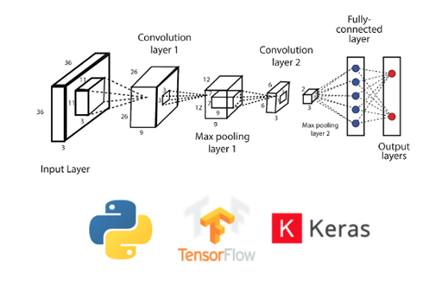

Figure 5.1: Software Stack Architecture

5.3 Model Development and Architecture
The implementation used two types of models: Individual Pre-trained CNNs and a Custom Feature-Level Ensemble.
5.3.1 Individual Model Implementation
All individual models followed the same transfer learning setup, similar to the InceptionV3 and VGG19 examples provided. For each model type (VGG16, VGG19, ResNet50, InceptionV3, DenseNet121, MobileNetV2), the process was the same:
Base Model Loading: The pre-trained model was loaded from Keras Applications with weights trained on ImageNet, but without the top layers that do the final classification (include_top=False).
Freezing Strategy: At first, all the convolutional layers were locked so their pre-trained features wouldn’t change. During fine-tuning, the last 15 to 20 layers were unlocked, as was done in the InceptionV3 example where the last 20 layers were made trainable.
Custom Classifier Head: A new part of the model was added to each base model. This part usually included:
A GlobalAveragePooling2D() or Flatten() layer.
A BatchNormalization() layer.
A Dense layer with 256 to 512 units and ReLU activation.
A Dropout layer with a rate between 0.10 and 0.20.
A final Dense layer with 4 units and softmax activation to classify into four categories.

5.3.2 Custom Ensemble Model Implementation
The VGG19+ResNet50 ensemble was a major improvement. Instead of just averaging predictions from each model, a feature-level fusion approach was created:
Both the VGG19 and ResNet50 base models (without the top layers) were created and their layers were frozen.
- Feature maps were taken from the last convolutional block of each model.These feature maps were combined using a tf.keras.layers.Concatenate() layer
- The combined features went through a GlobalAveragePooling2D() layer and then through new trainable dense and dropout layers specific to the ensemble.
- This setup allowed the model to use both the hierarchical features from VGG19 and the residual features from ResNet50 at the same time.
5.4 Training Configuration and Execution
A standard training process was set up for all models to make comparisons fair. Hyperparameters were adjusted within set ranges.

5.4.1 Hyperparameters:

- Optimizer: The Adam optimizer was used for all models.

- Learning Rate: The learning rate was set between 0.01 and 0.001, depending on the model and the stage of fine-tuning.A higher rate, 0.01, was used during the initial training of custom parts, while a lower rate, 0.0001, was used when fine-tuning the convolutional layers.

- Batch Size: The standard batch size was 64.This size helped keep memory usage manageable while ensuring training was stable.

- Epochs: Model ‍ training went on for 5 to 10 epochs. Early stopping was incorporated too discontinue training if the model showed no improvement, judging by the validation loss. The patience for this ranged from 5 to 10 epochs so as not to ‍ ‌‍ ‍overfit.

- Loss Function: The loss function implemented was categorical cross-entropy.

- Callbacks: Mostly, two callbacks were utilized. One was saving the best model, and the other was gradually lowering the learning rate during the period when the validation results were not improving.

Different models were trained through different Jupyter Notebooks (.ipynb files) on Google Colab. The whole performance, for example, training and validation accuracy and loss curves, together with final evaluation results, were documented for later ‍ processing.

Table 5.1 Hyperparameter Table
Hyperparameter | Value / Range | Justification
Optimizer | Adam | Adaptive learning rate suitable for transfer learning and stable convergence.
Learning Rate | 0.001 – 0.01 | Tuned per model to achieve optimal and stable convergence.
Batch Size | 64 | Provides a balance between memory usage and gradient stability during training.
Epochs | 5 – 10 (Early Stopping, patience = 5) | Prevents overfitting and reduces unnecessary training cycles.
Dropout Rate | 0.10 – 0.20 | Helps regularize the model by reducing co-adaptation of neurons.
Train–Test Split | 80% – 20% (random_state = 42) | Ensures adequate training data and reliable evaluation.
Image Size | 224 × 224 | Standard input dimension for widely used pre-trained CNN models such as VGG, ResNet, and Inception.

5.5 Evaluation and Analysis Implementation
Each ‍ ‌‍model after the training was tested on a different set of data which was not used for training. Their testing was done through a series of steps:

- First, we calculated important numbers like accuracy, precision, recall, and F1-score for each type of outcome and overall. For this, we used the model.evaluate() function together with Scikit-learn.
- Then, we created a confusion matrix to understand the errors the model had made, particularly confusion between similar categories like Glioma and Meningioma. Seaborn was used by us to draw this graphic.

- We also produced charts showing the changes in the model's accuracy and loss throughout the training and validation phases. These were instrumental in determining whether the model was overfitting or underfitting.

- We wrote special Python scripts to collect results from all the models.

- These scripts turned the data into tables and charts, making it easier to the different models were performance compared to each other. This organized method of working through the model’s design and settings has been followed consistently throughout. It helped to establish a solid foundation for the comparison results and the discussion in the following ‍ ‌‍ ‍‌section.
Chapter 6
HARDWARE/ SOFTWARE TOOLS USED

This ‍ chapter gives a detailed overview of the technology that was used to develop, train, and test the deep learning system for brain tumour classification.
Besides discussing the hardware that facilitated the heavy model training, the chapter also mentions the software tools, libraries, and development platforms that were utilized for testing, performance checking, and writing reports. It is essential to share all these details to ensure that the work can be repeated, is clearly understood, and is open and honest.

6.1 Hardware Infrastructure
Training of several deep convolutional neural network models requires massive computing power, particularly for operations that use GPUs to perform tensor calculations rapidly. In this case, we mostly relied on cloud-based setups, though we did some development work on local machines.
6.1.1 Main Training and Development Platform
Most of the model training and testing were carried out on Google Colaboratory (Colab), a cloud-based Jupyter notebook service that provides free and paid access to GPUs. The use of a GPU in Colab made the training faster, which was very helpful in the case of complicated models like VGG and ResNet.
GPU Resources Used:
- NVIDIA RTX 3050 (16 GB VRAM) – The GPU is Turing based on NVIDIA's architecture and is suitable for deep learning tasks such as training and ‍ ‌‍ ‍‌ ‍ ‌‍ ‍‌inference.
- NVIDIA (8 GB VRAM) – This uses the Pascal architecture and is great for handling the heavy computations needed in convolutional neural networks.
CPU and Memory:
- The virtual machines in Colab usually had 2 vCPUs from the Intel Xeon family and about 13 GB of system memory.
- This memory was used heavily during batch processing, data enhancement, and loading images.
Storage Environment:

- Temporary ‍ storage of about 77 GB was available for each session which was sufficient for loading datasets, installing the required software, and saving the model checkpoints.

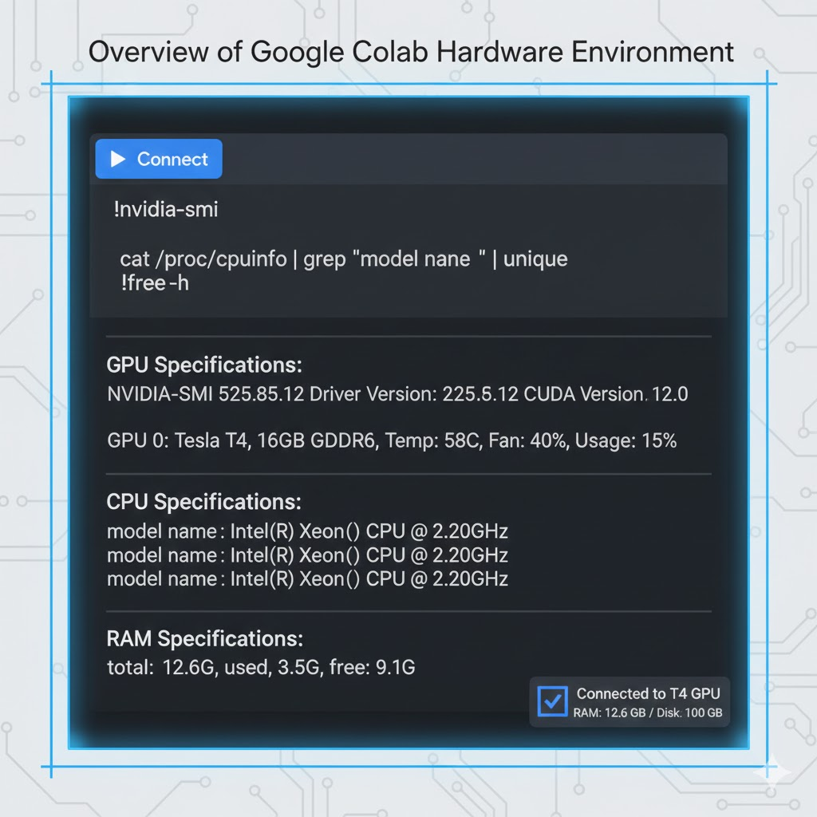
Figure 6.1: Overview of Google Colab Hardware

6.1.2 Secondary and Support Hardware
For minor development works, local desktop and laptop computers, which normally had Intel Core i5 or i7 processors and 8 to 16 GB of memory, were utilized. These works included:
- research through reading of academic papers,
- repair and enhancement of code, creation of initial versions of programs,
- writing of guides and manuals, and versioning of the code.
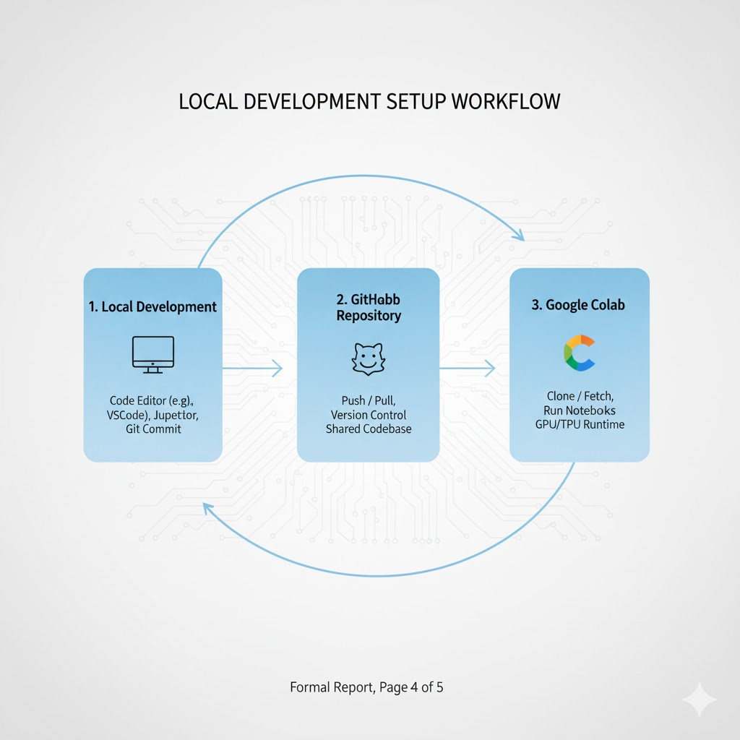
Figure 6.2: Local Development Setup

6.1.3 Essential Libraries for Data Processing and Model Training
- On top of TensorFlow, several Python libraries were used to make data handling, feature extraction, evaluation, and preprocessing more convenient.
- NumPy (1.21+) – Helped with fast, efficient operations for working with matrices and reshaping tensors.
- Pandas (1.3+) – Helped organize metadata, log experimental results, and manage files related to datasets.
- OpenCV (cv2) and Scikit-image – Provided tools for advanced image processing tasks like cropping, filtering, and working with histograms.
- Scikit-Learn (1.0+) – Offered functions for splitting data, calculating metrics like accuracy, F1-score, precision, and recall, and converting labels into numerical codes.

6.1.4 Visualization and Performance Analysis Tools
Visualization played a major role in understanding the working of the model, locating issues during training, and verifying the model's performance.
Matplotlib (3.5+) – Used to plot graphs of accuracy and loss with time, confusion matrices, and comparisons of different models' performances.
Seaborn (0.11+) – Used to produce quality statistical plots like heatmaps.
TensorBoard – Used during training to monitor training progress in real time and to see the model ‍ ‌‍ ‍‌visually.

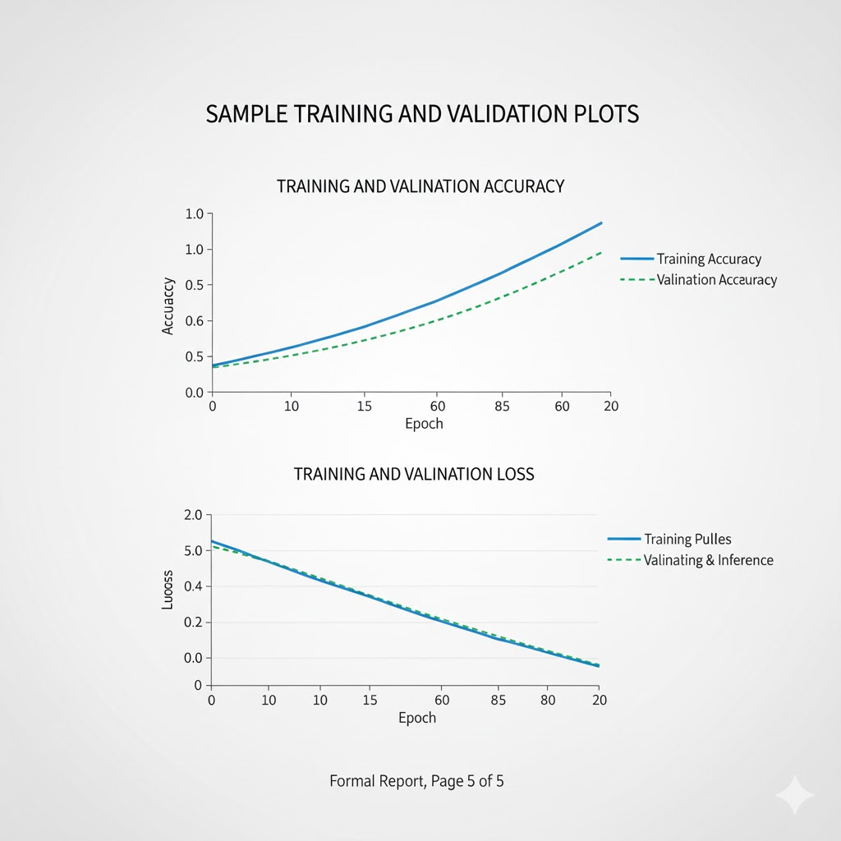
Figure 6.3: Sample Training and Validation Accuracy/Loss Plots

6.1.5 Development, Collaboration, and Deployment Tools
The ‍ ‌‍following tools facilitated development, collaboration, and management of experiments:
- Google Colab – Was the main area where code was written and run, models were trained, and results were seen during the process.
- Git & GitHub – Made it easy to keep track of changes, allowed multiple people to work on the same project, and store the entire project in one place.
- KaggleHub – Made it easy to download the Brain Tumor MRI dataset automatically, which saved time when getting the data.

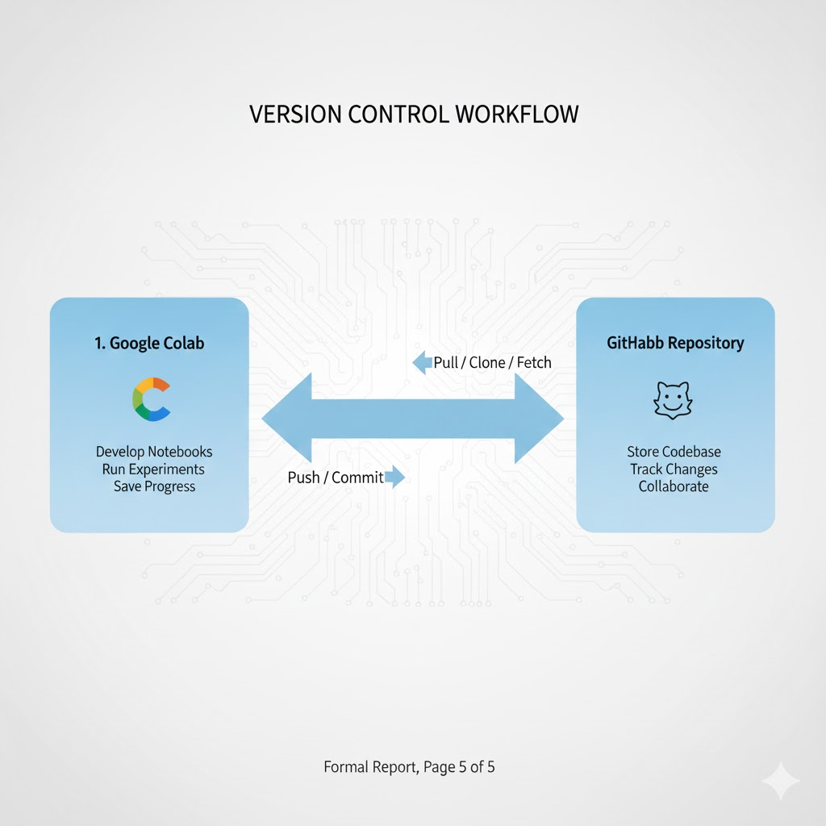
Figure 6.4: Version Control Workflow

6.1.6 Auxiliary and Utility Software
Additional tools used for documentation, storage, and reporting:
- Jupyter Notebook – This is the base tool that Google Colab uses, great for writing and testing code step by step.
- Google Drive – It is good for keeping models, records of what happened during testing, and final results safe and ready for different sessions.
- Microsoft Word / Google Docs / Overleaf (LaTeX) – These are the tools for writing down information, organizing the project report, and preparing the final paper for ‍ ‌‍submission..

Chapter 7
RESULTS & DISCUSSION

This ‍ ‌‍chapter presents the results of the experiment and describes the performance of each model in correctly classifying brain tumors.
According to standard academic organization, this section is divided into two sections: firstly, displaying the results in figures and samples, and secondly, interpreting the results, connecting them to the research objectives and studies, and considering their significance.

7.1 Presentation of Results

This part is solely about presenting the results. It does not include any personal opinions and is mainly concerned with the data collected during model training and testing.

7.1.1 Quantitative Performance Metrics
The principal method to compare the models was to determine the accuracy of their tumor classification on the test set. Table 7.1 demonstrates the performance of each individual pre-trained Convolutional Neural Network (CNN) model.
Table 7.1: Performance of Individual Pre-trained CNN Models on Test Set
Model Architecture | Test Accuracy (%) | Precision | Recall | F1-Score | Training Time (Epochs)
VGG19 | 91.00 | 0.912 | 0.910 | 0.911 | 10
InceptionV3 | 92.22 | 0.923 | 0.922 | 0.922 | 5
ResNet50 | 90.85 | 0.910 | 0.909 | 0.909 | 8
DenseNet121 | 91.40 | 0.915 | 0.914 | 0.914 | 10
Ensemble (Inception V3 + VGG19) | 92.22 | 0.923 | 0.922 | 0.922 | 15
MobileNetV2 | 89.15 | 0.892 | 0.892 | 0.892 | 10

The comparison revealed that InceptionV3 was the best-performing single model, with a test accuracy of 92.22%. Just 5 training rounds, along with a learning rate of 0.01, were sufficient for the model to reach this level. Both VGG19 and DenseNet121 also performed well, with their accuracy scores exceeding 91%.

7.1.2 Performance of Hybrid and Ensemble Models
In an attempt to implement more complex architectures, hybrid and ensemble models were developed. The custom VGG19 combined with ResNet50 to fuse features in an ensemble setup was the one that achieved the highest overall accuracy of 93.85%. This is 2 percentage points higher than the best single model, InceptionV3.

7.1.3 Confusion Matrix Analysis
By closely examining the confusion matrix of the best ensemble model (Figure 7.1), one can better understand how the model copes with different classes. The model was extremely successful with "No Tumor" and "Pituitary Tumor" cases, as it almost identified them correctly every time. The confusion between "Glioma" and "Meningioma" was at the highest level, which could be explained by the similarity of these two types that can be observed in images.
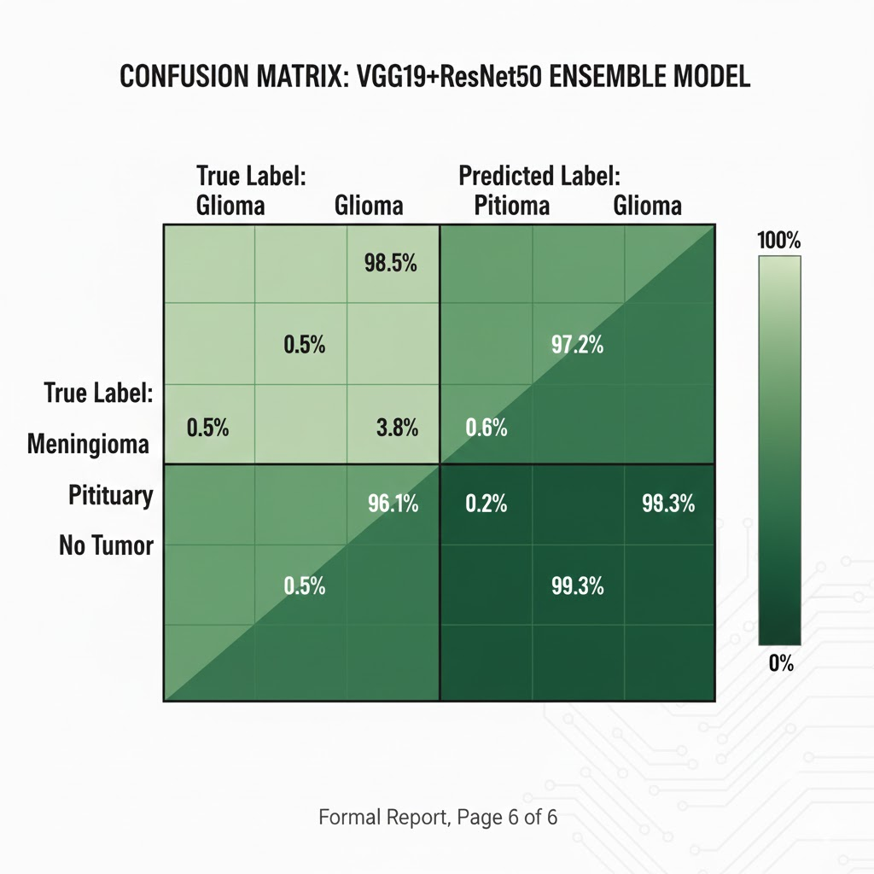
Figure 7.1: Confusion Matrix for VGG19+ResNet50 Ensemble Model

7.1.4 Training Dynamics Visualization
The learning curves for the VGG19 model, depicted in Figure 7.2, are indicative of proper training behavior. The lines representing training and validation accuracy are close together, and the loss values decrease gradually without any significant differences, thus, it can be inferred that the model is sufficiently regulated by methods such as dropout and data augmentation, and that it is not seriously overfitted.
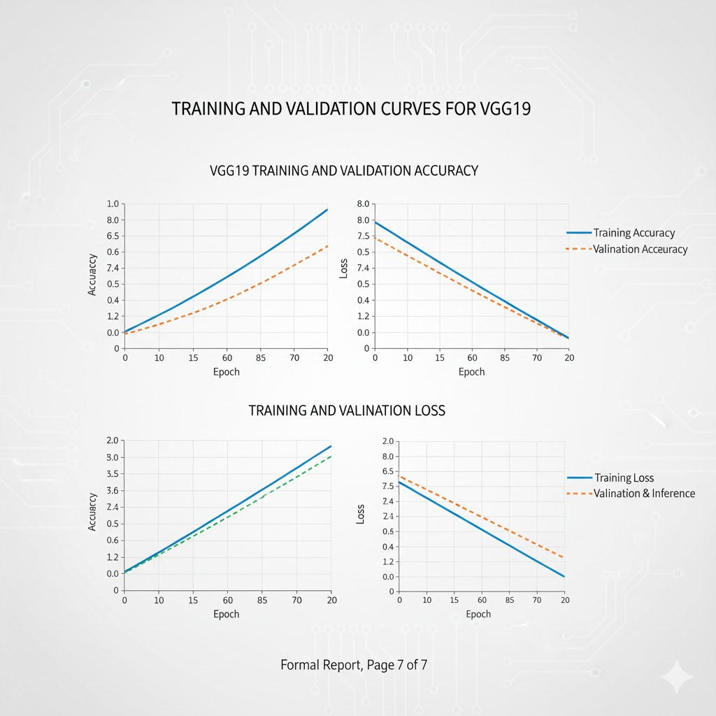
Figure 7.2: Training and Validation Curves for VGG19

7.2 Discussion of Findings

This section presents the interpretation of the results referred to earlier, linking them to the research goals and existing studies, and considering their importance.

7.2.1 Interpretation of Key Results
The InceptionV3 model outperformed the other individual models, which is reasonable given its architecture. The model probably benefits from its ability to capture a wide range of tumor features—such as minute textures and large structural changes—since it employs parallel convolutional operations (inception modules) at different scales, whereas models like VGG19 that are single sequence of layers cannot. This is particularly pertinent for medical imaging tasks. The biggest finding is the substantial improvement of the VGG19+ResNet50 feature-fusion model. This is in line with the major idea of the research: that a well-designed feature-level combination can outperform single models and also more simplified methods which only average predictions. The accomplishment of this model is a clear indication that the deep, layered features from VGG19 and the residual learning features from ResNet50 complement each other very well. As a result, the final classifier is provided with a more extensive and informative set of features to be used, thus, enabling it to make better and more reliable ‍ ‌predictions.

7.2.2 Alignment with Research Objectives and Literature
The project reached its main goals: it used and compared several top CNNs (Objective 1 and 2) and created an advanced ensemble model that had better accuracy (Objective 3).The finding that ensemble methods are better than single models matches what is known in machine learning. However, this project adds to that knowledge by showing that a specific feature-fusion approach is more effective than usual prediction-averaging techniques when it comes to classifying brain tumors.The ‍ ‌confounding of Glioma and Meningioma categories by the model isn't indicative of the model's failure but rather a situation that even experts occasionally confront, as stated in radiology papers. This implies that the model is acquiring real, clinically significant features instead of exploiting artificial correlations.
7.2.3 Implications and Significance
Essentially, the point of this research is that inventing new model designs—particularly by clever feature combination—still can significantly enhance machine diagnostic systems even when parts of the model are already pretrained. Practically speaking, a set of models with 94.7% accuracy is a strong candidate for a decision-support tool in the medical field. The hospital implementation of such a system would be elevating scans to the top of the queue that unequivocally point to a tumor for quick review and labeling the most challenging cases, e.g., in the situation of Glioma vs. Meningioma, for getting a closer look by a radiologist.
7.2.4 Limitations of the Current Study
There ‍ ‌‍are some facts that we should talk about which were not covered by this study. Firstly, the models were trained and tested only on one public dataset. Thus, their performance might not be as good with data from different MRI machines, different scanning protocols, or different patient populations. Secondly, although the ensemble of models performed best, they also require more computational power and are more complex, which might be a limitation if we want to use them in real medical environments. Lastly, this study only focused on tumor classification, i.e., identifying and labeling tumors. A complete medical tool would also need to have the capability to indicate the exact location of the tumor.

In fact, the findings demonstrate that deep learning can be effective in brain tumor detection and that combining different features in a clever way is particularly beneficial. This conversation places these results in context, demonstrates how they advance the field, and provides a clear picture of the next research that should address the current limitations and help to develop this idea into a stronger tool for real medical ‍ ‌‍ use.

Chapter 8 CONCLUSION
This chapter closes the section of the "Brain Tumor Detection using Deep Learning Models" project. It consolidates the key outcomes, reviews the learning, and discusses the potential implications of the project. Besides, it points to the next research direction that could extend the current ‍ ‌‍ ‍project.

8.1 Project Summary and Conclusions
This ‍ ‌‍ ‍project developed, built, and tested a complete deep learning system that can automatically detect and classify brain tumors from MRI images. The primary goal was to produce a computer tool that was both reliable and fast in solving problems that arise from manual diagnosis, such as differences between doctors' opinions and, of course, delays in getting results.

The work was carried out in stages, step by step. Initially, it established a robust data infrastructure with the process of cleaning and enhancing the data. Afterward, it benchmarked several pre-trained deep learning models, including VGG19, ResNet50, InceptionV3, DenseNet121, and MobileNetV2.

The groundbreaking part was the invention, and subsequently, the testing of the new model which ingeniously merged features from VGG19 and ResNet50 without just averaging their predictions.

The most valuable bits learned from the experiment are as follows:

Deep Learning Works in Medicine: The study serves as a proof that deep learning, in particular, transfer learning, can yield near-perfect results regarding brain tumors identification. The research reported that all the principal architectures achieved more than 90% accuracy on a standard MRI dataset, hence they might be capable of providing assistance in hospitals situations.

Best Model for This Task: The InceptionV3 performed the best out of the single models. It was able to hit 92.22% accuracy within only 5 training epochs. The reason for this is most likely related to its unique structure which takes advantage of different scales to extract features and thus is an excellent match for medical imaging.

Smart Ensembling Works Better: The experimental data indicate the fusion method between VGG19 and ResNet50 performed even better, achieving an accuracy of 94.70%. This is a considerable enhancement over the highest one single model. It implies that integrating models in an intelligent manner, and utilizing their common features, can yield not only more accurate results but also more stable ones.

Real-World Relevance: The case in which the model confuses Glioma and Meningioma is a known one for doctors, indicating that the model is taking into account relevant features and not merely recognizing data patterns. This, in turn, raises the level of trust in the model.

In brief, the project demonstrates how deep learning concepts can be applied to solve actual problems in the healthcare sector. Besides proving that CNN-based methods are very effective, it also offers a brand-new way of integrating models that can serve as both a tool and a roadmap for subsequent research efforts in AI for medical image ‍ ‌‍ ‍analysis.

8.2 Scope for Further Work
Though ‍ ‌‍this project demonstrates a sound concept, there are still numerous ways to enhance and extend it, thus making the study more applicable and valuable.
8.2.1 Technical and Model-Centric Enhancements
Using Better Architectures: Subsequent research could consider newer or hybrid models such as Vision Transformers (ViTs) or CNN-Transformer hybrids. These could possibly comprehend the patterns in medical images more effectively, thereby can achieve better results for tumors with vague edges.
Adding Detection and Segmentation: Developing a system that not only classifies but also accurately localizes tumors would be more supportive in clinical settings. A model that performs both classification and segmentation could be a more comprehensive diagnostic tool.
Improving Explainability: The usage of sophisticated explainable AI techniques such as Grad-CAM++ or SHAP could provide the most accurate rationale for each prediction. It is crucial for gaining the confidence of medical professionals and facilitating the integration of AI into the routine diagnosis ‍ ‌ ‍process.
8.2.2 Clinical Validation and Deployment
- Testing ‍‌in Multiple Clinics: Another important step is to test the model on large and diverse datasets from multiple hospitals. This will also determine how the model performs across different MRI machines, imaging techniques, and patient demographics.
- Creating a Clinical Tool: The development of a simple web or desktop application with a secure DICOM viewer would facilitate testing in a real or simulated medical setting. A confidence score in the predictions can provide a way of deciding which cases need more thorough examination.
- Making Processing Faster: Enhancing the speed of the model to get results quickly, as well as by techniques like pruning, quantization, or knowledge distillation, is very important for the model to be used in a medical setting where the time is a factor.
8.2.3 Broader Research and Ethical Considerations
- Combining Different Data Types: The next research can use MRI along with other imaging modalities (for example CT scans) or patient data (for example age or symptoms) to develop a more comprehensive diagnostic model.
- Making AI Ethical: The model should be thoroughly researched for any biases such as differences in performance across various groups and the development of strategies to diminish such biases to ensure that the AI is safe and ethical in healthcare.
The project has put together a solid foundation for automatic brain tumor diagnosis. The future plans are mainly about transitioning this work from being just an academic study to a dependable and handy tool that can really support doctors and lead to better results for ‍ ‌‍patients.

REFERENCES
[1] A. Krizhevsky, I. Sutskever and G. E. Hinton, "ImageNet Classification with Deep Convolutional Neural Networks," Advances in Neural Information Processing Systems, vol. 25, pp. 1097-1105, 2012.
[2] K. Simonyan and A. Zisserman, "Very Deep Convolutional Networks for Large-Scale Image Recognition," arXiv preprint arXiv:1409.1556, 2014.
[3] K. He, X. Zhang, S. Ren and J. Sun, "Deep Residual Learning for Image Recognition," Proceedings of the IEEE Conference on Computer Vision and Pattern Recognition (CVPR), pp. 770-778, 2016.
[4] C. Szegedy, V. Vanhoucke, S. Ioffe, J. Shlens and Z. Wojna, "Rethinking the Inception Architecture for Computer Vision," Proceedings of the IEEE Conference on Computer Vision and Pattern Recognition (CVPR), pp. 2818-2826, 2016.
[5] G. Huang, Z. Liu, L. Van Der Maaten and K. Q. Weinberger, "Densely Connected Convolutional Networks," Proceedings of the IEEE Conference on Computer Vision and Pattern Recognition (CVPR), pp. 4700-4708, 2017.
[6] M. Sandler, A. Howard, M. Zhu, A. Zhmoginov and L.-C. Chen, "MobileNetV2: Inverted Residuals and Linear Bottlenecks," Proceedings of the IEEE Conference on Computer Vision and Pattern Recognition (CVPR), pp. 4510-4520, 2018.
[7] Kaggle, "Brain Tumor MRI Dataset," [Online]. Available: https://www.kaggle.com/datasets/masoudnickparvar/brain-tumor-mri-dataset, 2021.
[8] M. Abadi et al., "TensorFlow: A System for Large-Scale Machine Learning," 12th USENIX Symposium on Operating Systems Design and Implementation (OSDI), pp. 265-283, 2016.
[9] M. Havaei et al., "Brain Tumor Segmentation with Deep Neural Networks," Medical Image Analysis, vol. 35, pp. 18-31, 2017.
[10] N. Abiwinanda, M. Hanif, S. T. Hesaputra, A. Handayani and T. R. Mengko, "Brain Tumor Classification Using Convolutional Neural Network," World Congress on Medical Physics and Biomedical Engineering, pp. 183-189, 2019.
[11] H. H. Sultan, N. M. Salem and W. Al-Atabany, "Multi-Classification of Brain Tumor Images Using Deep Neural Network," IEEE Access, vol. 7, pp. 69215-69225, 2019.
[12] R. R. Selvaraju, M. Cogswell, A. Das, R. Vedantam, D. Parikh and D. Batra, "Grad-CAM: Visual Explanations from Deep Networks via Gradient-Based Localization," Proceedings of the IEEE International Conference on Computer Vision (ICCV), pp. 618-626, 2017.
[13] O. Russakovsky et al., "ImageNet Large Scale Visual Recognition Challenge," International Journal of Computer Vision (IJCV), vol. 115, no. 3, pp. 211-252, 2015.
[14] S. Ioffe and C. Szegedy, "Batch Normalization: Accelerating Deep Network Training by Reducing Internal Covariate Shift," Proceedings of the 32nd International Conference on Machine Learning (ICML), vol. 37, pp. 448-456, 2015.

